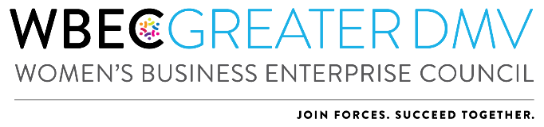

2023 Outstanding Women’s Business Advocate Award Application
*NOTE: Only ONE application can be submitted per region.

Each year the Outstanding Women’s Business Advocate Award recognizes an individual (either a WBE or Corporate Member) who has supported to the Greater DMV and to other women in business.

The Awardee will receive:
- Recognition at the Celebrating Our Partners Reception and Annual Awards Breakthrough Breakfast on November 16 & 17, 2023.
- Profile on the organization website.
- Identification as an awardee at other signature programs including the Breakthrough Breakfast in NY.
- Opportunity to participate on the 2024 Awards Committee

Criteria:
The Outstanding Women’s Business Advocate will be recognized for the following criteria:
- Active involvement with Greater DMV – 25 points
- Significant contributions to Greater DMV (this can be in time, finances, in-kind contributions, expertise, etc.) – 30 points
- Support of women-owned businesses – 25 points
- Recommendation and Reference Information – 20 points

Application Process:
Corporate representatives, WBEs and Alliance Partners are invited to apply for this award and encourage others to apply if their companies meet the above criteria. To apply:
- Answers to application questions should reflect activity for the 2022 calendar year.
- Nominee must answer all application questions on the application and submit one letter of recommendation from a current or previous corporation or WBE supplier.
- All applications should be received no later than Friday August 11, 2023.
- Applications will be reviewed by a committee. Finalists will be notified by Wednesday September 6, 2022.
- Please note that an advocate cannot win the same award in two consecutive years.

Additional Information/Instructions:
- Each answer should not exceed one page.
- All sections should be completed in the format most appropriate for your response, e.g., narrative, outline, etc.
- Applications must be submitted in one complete package. Applications will not be accepted if components are submitted separately.
- Additional materials such as photographs, brochures, and marketing materials will not be accepted.
- Application, company logo and headshot of person who would accept the award should be emailed to: WBEC Greater DMV Awards at awardsdmv@wbecgreaterdmv.org

Nominee Name:
Company:
Nominee Email Address:

  - List activities and provide a brief description of the nominee’s involvement with Greater DMV.

  - List three (3) significant contributions the nominee has made to Greater DMV in the past year.

  - List the contributions the nominee has made to women-owned businesses in the past year and provide a description of how they affected the women’s business community.

  - Recommendation and Reference Information
Please attach your letter of recommendation from a corporation or WBE that addresses how you fulfill the awards criteria when you submit your application.

