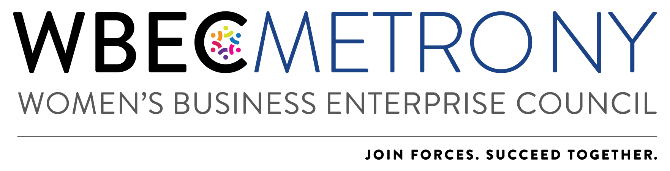

2022 Star Award Application
*Please NOTE: Only ONE application can be submitted per region.

Every year our organization celebrates its outstanding WBEs. The Star Award recognizes the top certified woman-owned businesses that have contributed to WBEC Metro NY, have championed other women in business and developed innovative solutions to doing business with Corporations.

2021 was anything but usual, so please adapt your answers as relative to our continued virtual work & meeting environment.

The 2022 Star Award winner will receive:
- Recognition at the Annual Awards Event on March 4, 2022.
- Profile on the organization website
- Opportunity for a spokesperson role at Metro Educational Programs
- Both the NY and DMV 2022 Stars will be selected for participation on the 2023 Awards Committee

The outstanding WBE award is presented annually at the Annual Awards Breakfast celebration in March to a company (not an individual) that meets the following criteria:
- Current WBENC certification issued through WBEC Metro NY
- Has previously or is currently doing business with a WBENC Corporate Sponsor and has participated in the Done Deals™ Program
- Utilizes innovative solutions to leverage WBENC Certification
- Has actively attended and participated in Metro NY events & programs
- Demonstrates involvement with the Metro NY (volunteer service, in-kind support, event sponsorship, committee participation, panelist participation etc.)
- Actively supports fellow certified WBEs

Application Process:
- Nominee WBEs are encouraged to apply for this award and recommend that other WBEs to apply if they meet the above criteria.
- In order to apply, the WBE must answer all application questions and submit one letter of recommendation from a corporation or WBE to address the above criteria.
- All application materials should be submitted no later than Wednesday February 16, 2022.
- Applications will be reviewed by a committee and winners will be notified by Friday, February 25, 2022.
- Please note that WBEs cannot win the same award in two consecutive years.

Additional Information/Instructions:
- Answers should not exceed one page per question.
- All sections should be completed in the format most appropriate for your response, e.g. narrative, outline, etc.
- Full application, including questionnaire responses and letter of recommendation must be submitted in one complete package. Materials will not be accepted if submitted separately.
- Additional materials such as photographs, brochures, and marketing materials will not be accepted.
- Application, company logo and headshot of person who would accept the award should be emailed to:
WBEC Metro NY Awards awardsny@wbecmetrony.org

Nominee Name:
Company:
Email Address:

  - Involvement with Metro NY
Please assess the level of your past and present involvement with Metro NY. Include information on the events you attended, Done Deals™ reported, marketing methods for WBENC certification, volunteer efforts, in-kind services, referrals, committee participation, etc.

Please check the appropriate boxes:

Attended Breakthrough Breakfast

Attended additional educational programs

Referred another woman business owner to the Metro NY

Volunteered time and/or expertise to the Metro NY

Placed the WBENC logo and/or women-owned logo on marketing materials, and/or website

Reported a Done Deal

Referred a corporate client (who is not a WPEO corporate member) to the Metro NY

Presented at a Lunch with the Experts webinar

Sponsored a Metro NY program

Other Metro NY collaborations

None of the above

  - WBE Experience
a. In 100 words or less, please describe what WBE certification means to your company.

b. Include innovative strategies you have used to leverage your certification and provide anything else about marketing your certification that you believe is relevant to the award.

  - Support for other WBE Businesses
Explain how your business utilizes or partners with other WBEs and/or other diverse vendors (up to 3 examples).

  - WBE Experience
a. In reviewing the nomination for this award, what other factors should be considered, e.g. cost-effective solution(s) for clients, innovative marketing solutions, expertise, etc.?

b. Please list the nominee’s revenues

Current:
Last Full Year:

  - Recommendation and Reference Information
Please attach your letter of recommendation from a corporation or WBE that addresses how you fulfill the awards criteria when you submit your application.

