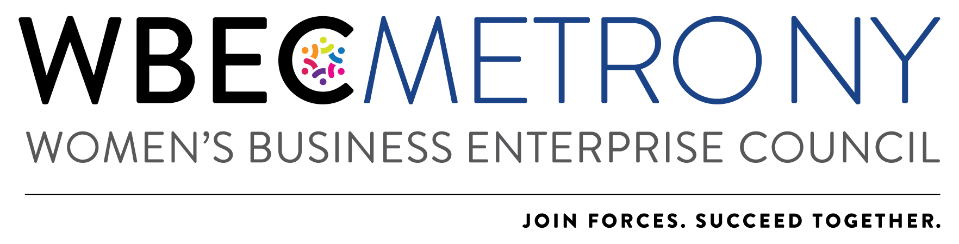

2022 Outstanding Women’s Business Advocate Award Application
*Please NOTE: Only ONE application can be submitted per region.

Each year the Outstanding Women’s Business Advocate Award recognizes an individual (either a WBE or Corporate Member) who has supported the Metro NY and other women in business.

2021 was anything but usual, so please adapt your answers as relative to our continued virtual work & meeting environment.

The Awardee will receive:
- Recognition at the Annual Awards Event on March 4, 2022.
- Visibility in public relations supporting the event
- Opportunity to participate on the 2023 Awards Committee
- One winner will be selected from each region (NY and DMV)

Criteria: The Outstanding Women’s Business Advocate will be recognized for the following criteria:
- Active involvement with Metro NY
- Significant contributions to Metro NY (this can be in time, finances, in-kind contributions, expertise, etc.)
- Support of women-owned businesses.

Application Process:
Corporate representatives, WBEs and Alliance Partners are invited to apply for this award and encourage others to apply if their companies meet the above criteria. To apply:
- Nominees must answer all application questions on the application and submit one letter of recommendation from a current or previous corporation or WBE supplier.
- All applications should be received no later than Wednesday February 16, 2022.
- Applications will be reviewed by a committee. Winners will be notified by Friday February 25, 2022.
- Please note that an advocate cannot win the same award in two consecutive years.

Additional Information/Instructions:
- Each answer should not exceed one page.
- All sections should be completed in the format most appropriate for your response, e.g., narrative, outline, etc.
- Applications must be submitted in one complete package. If components are submitted separately the application will not be accepted.
- Additional materials such as photographs, brochures, and marketing materials will not be accepted.
- Application, company logo and headshot of person who would accept the award should be emailed to:
WBEC Metro NY Awards awardsny@wbecmetrony.org

Nominee Name:
Company:
Email Address:

  - List activities and provide a brief description of the nominee’s involvement with Metro NY.

  - List three (3) significant contributions the nominee has made to Metro NY in the past two years.

  - List the contributions the nominee has made to women-owned businesses in the past year and provide a description of how they affected the women’s business community.

  - Recommendation and Reference Information
Please attach your letter of recommendation from a corporation or WBE that addresses how you fulfill the awards criteria when you submit your application.

