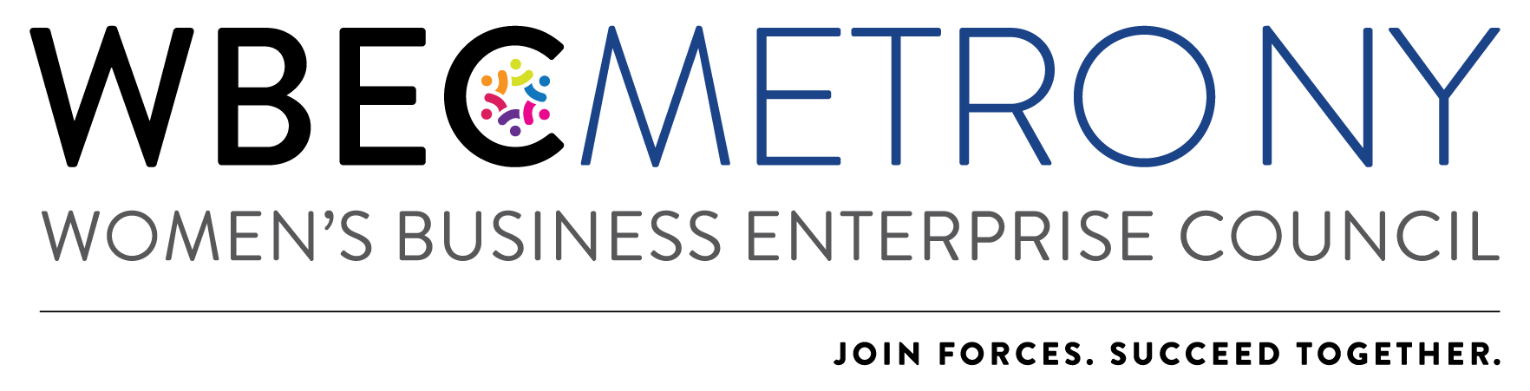

2022 Outstanding Corporation Award Application
*Please NOTE: Only ONE application can be submitted per region.

Each year the Outstanding Corporation Award recognizes a WBEC Metro NY Corporate Member who has demonstrated exceptional commitment to the organization, has supported women in business or developed innovative resources and initiatives to increase supplier diversity opportunities.
2021 was anything but usual, so please adapt your answers as relative to our continued virtual work & meeting environment.

Corporate award winners will receive:
- Recognition at the Annual Awards Event on March 4, 2022.
- Identification as an awardee at other signature programs including the Breakthrough Breakfast in NY and the Access Reception in Washington, DC.
- Participation on the 2023 Awards Committee

Criteria: The Corporation receiving this award will be recognized for the following criteria, based on a point system:
- Contribution to WBEC – 15 points
- Communications about your commitment to Supplier Diversity – 20 points
- Access to Supply Chain – 10 points
- WBE Collaboration and Communication – 20 points
- Metro NY’s Value to Company – 15 points
- Top Management and C-Level Executive Involvement – 10 points
- Metro NY Sponsorship – 10 points
The Corporate Member receiving the highest total number of points will be selected.

Application Process:
Corporate representatives are invited to apply for this award and encourage other corporations to apply if their companies meet the above criteria. To apply:
- Nominees must answer all questions on the application and submit one letter of recommendation from a current or previous WBE supplier.
- All applications should be received no later than Wednesday February 16, 2022.
- Applications will be reviewed by a select committee and winners notified by Friday February 25, 2022.
- Please note that a corporation cannot win the same award in two consecutive years.

Additional Information/Instructions:
- Each answer should not exceed one page.
- All sections should be completed in the format most appropriate for your response, e.g., narrative, outline, etc.
- Applications must be submitted in one complete package. Applications will not be accepted if components are submitted separately.
- Additional materials such as photographs, brochures, and marketing materials will not be accepted.
- Application, company logo and headshot of person who would accept the award should be emailed to:
WBEC Metro NY Awards awardsny@wbecmetrony.org

Nominee Name:
Company:
Email Address:

  - Contribution to WBEC Metro NY
List three (3) significant contributions that your company has made to Metro NY in any of the following areas: time, service, or membership. Please be as specific as possible.

  - Communications about your commitment to Supplier Diversity
List the specific ways in which your company communicates internally about the importance of Supplier
Diversity (including employee newsletters, awards, recognition, and incentives for achieving diverse
supplier objectives).

Does the nominee’s company have a policy regarding supplier diversity as it relates to procurement?

Yes No

  - Access to Supply Chain
List three (3) ways in which your company has increased access to your supply chain for women’s business enterprises. Be specific and provide quantitative results if possible (e.g., How do you know your actions have increased access to the supply chain?).

  - WBE Collaboration and Communication

a. Do you require certification? Yes No

b. Do you host workshops or introduce your female vendors to WBEC Metro NY? Yes No

c. What information do you convey to female vendors about the certification process?

d. Please provide the number of Done Deals your company has completed with certified WBEs in the
past year.

e. Did you report them to the WBEC? Yes No

f. What are your goals for WBE spend next year? $

g. Do your goals for next year represent an increase, a decrease or are they the same?
Increase Decrease Same

h. Do you have a 2nd tier program? Yes No N/A

i. If yes, does the nominee introduce prime suppliers to WBEs? Yes No N/A

j. If yes, does the nominee write diversity requirements into prime supplier contracts?
Yes No N/A

k. What is the nominee’s company total spend with WBEs in the WBEC Metro NY RPO:

$

l. How many WBEs did you include in Requests for Information (RFIs) and Requests for Proposals

RFPs: RFIs: N/A:

m. Please quantify your increased year-over-year spend in WBEC Metro NY region:

  - Metro NY’s Value to Company
List three to five ways in which WBEC Metro NY has provided value to the nominee’s company in the past year. Be specific.

  - Top Management and C-level Executive Involvement

Indicate whether top Management or C-level executives from your company have provided support at any of our 2021 Virtual Event offerings:

  - Metro NY Sponsorship

Is the nominee’s company in good standing relative to its WBEC Metro NY membership fee?

Yes No N/A

